# **Name: Abdurrahman Qureshi**

# **Roll No: 210451**

Practical No: 6

**1)Generate the following output:**

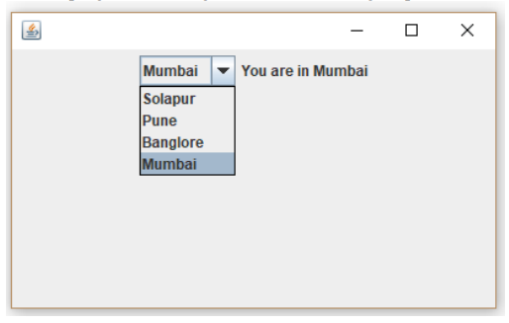

**CODE:**

import javax.swing.*;

import java.awt.*;

import java.awt.event.*;

public class Main {

public Main() {

JFrame frame = new JFrame("My City Selector");

JPanel panel = new JPanel();

panel.setLayout(new GridLayout(2, 1));

panel.setBackground(Color.DARK_GRAY);

JComboBox<String> comboBox = new JComboBox<>();

comboBox.addItem("Solapur");

comboBox.addItem("Pune");

comboBox.addItem("Bangalore");

comboBox.addItem("Mumbai");

comboBox.setBackground(Color.DARK_GRAY);

comboBox.setForeground(Color.WHITE);

JLabel label = new JLabel("You are in: ");

label.setForeground(Color.WHITE);

comboBox.addActionListener(new ActionListener() {

@Override

public void actionPerformed(ActionEvent e) {

String selectedCity = (String) comboBox.getSelectedItem();

label.setText("You are in: " + selectedCity);}});

comboBox.setSize(200, 30);

label.setSize(200, 30);

panel.add(comboBox);

panel.add(label);

frame.add(panel);

frame.setBackground(Color.DARK_GRAY);

frame.setSize(400, 150);

frame.setDefaultCloseOperation(JFrame.EXIT_ON_CLOSE);

frame.setVisible(true);}

public static void main(String[] args) {

new Main();}}

**OUTPUT:**

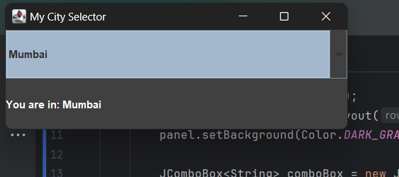

**2)Select states using the above program**

**CODE:**

import javax.swing.*;

import java.awt.*;

import java.awt.event.*;

public class Main {

public Main() {

JFrame frame = new JFrame("My State Selector");

JPanel panel = new JPanel();

panel.setLayout(new GridLayout(2, 1));

panel.setBackground(Color.DARK_GRAY);

JComboBox<String> comboBox = new JComboBox<>();

comboBox.addItem("Maharashtra");

comboBox.addItem("Kerela");

comboBox.addItem("Bihar");

comboBox.addItem("Goa");

comboBox.setBackground(Color.DARK_GRAY);

comboBox.setForeground(Color.WHITE);

JLabel label = new JLabel("You are in: ");

label.setForeground(Color.WHITE);

comboBox.addActionListener(new ActionListener() {

@Override

public void actionPerformed(ActionEvent e) {

String selectedCity = (String) comboBox.getSelectedItem();

label.setText("You are in: " + selectedCity);

}});

comboBox.setSize(200, 30);

label.setSize(200, 30);

panel.add(comboBox);

panel.add(label);

frame.add(panel);

frame.setBackground(Color.DARK_GRAY);

frame.setSize(400, 150);

frame.setDefaultCloseOperation(JFrame.EXIT_ON_CLOSE);

frame.setVisible(true);}

public static void main(String[] args) {

new Main();}}

**OUTPUT:**

**3)Develop a program to demonstrate the use of ScrollPane in Swings**

**CODE:**

import javax.swing.*;

import java.awt.*;

public class Main {

public Main() {

JFrame frame = new JFrame("My ScrollPane Demo");

JTextArea JTA = new JTextArea(20,20);

for (int i = 1 ; i<=100 ; i++){

JTA.append("Line number " + i + "\n");}

JTA.setBackground(Color.DARK_GRAY);

JTA.setForeground(Color.WHITE);

JScrollPane JSP = new JScrollPane(JTA);

frame.add(JSP);

frame.setSize(400, 300);

frame.setDefaultCloseOperation(JFrame.EXIT_ON_CLOSE);

frame.setVisible(true);}

public static void main(String[] args) {

new Main();}}

**OUTPUT:**

